# Best Management Practices to Build Soil Health - Cropland

Name:________________________________________

Congratulations! You just inherited your grandparent’s farm in north central Iowa. It is 640 acres of cropland that has historically been in a corn-on-corn planting cycle. See the map of the property below. The red line indicates the property boundaries. Other features like fields and houses should be somewhat distinguishable.

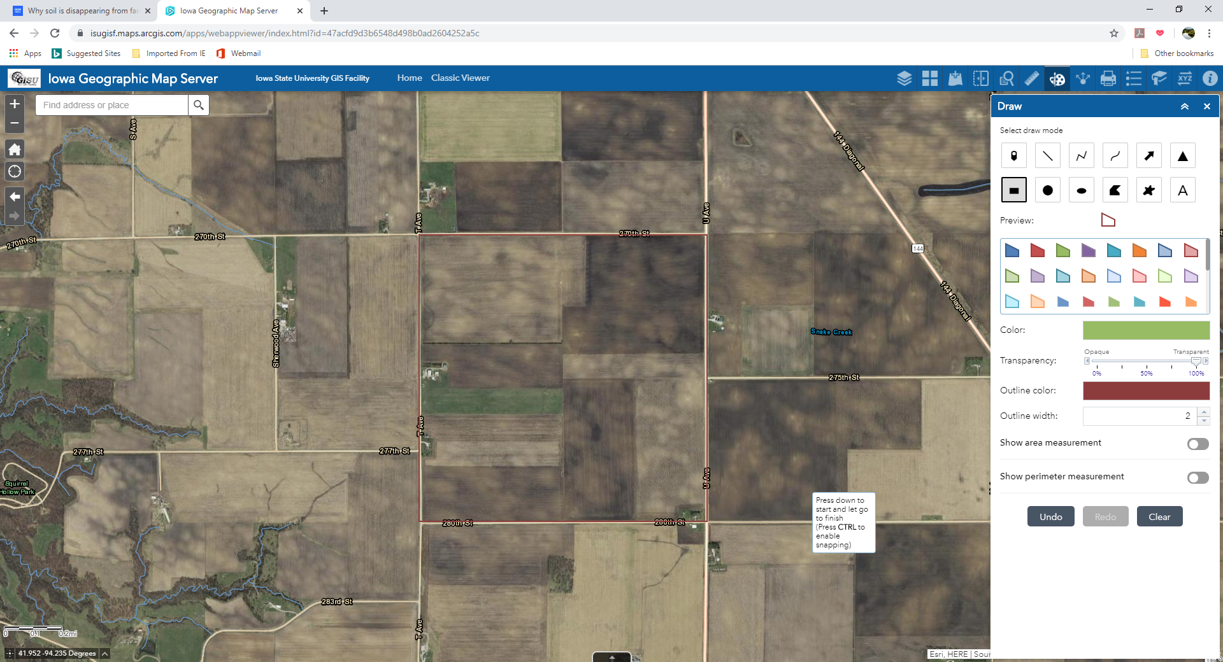

Over the past several years, the corn yield has started to decline. The previous managers have had to add more and more fertilizer to maintain yield. You want to improve the soil health and reduce input costs like fertilizer. As the new manager, you are conscious about climate change and you know that improving soil health can help capture carbon.

Challenge: Design a system for minimizing soil erosion and building soil health to increase crop yield on the farm.

1. Identify what best management practices for increasing soil health you will implement on your farm. Explain why you chose that practice and how you will implement it.
2. Be prepared to present your plan with the class.